Friday 8th April
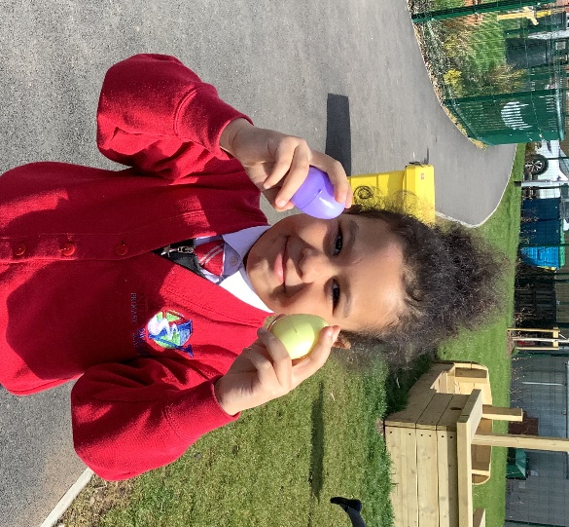
Easter Egg Hunt
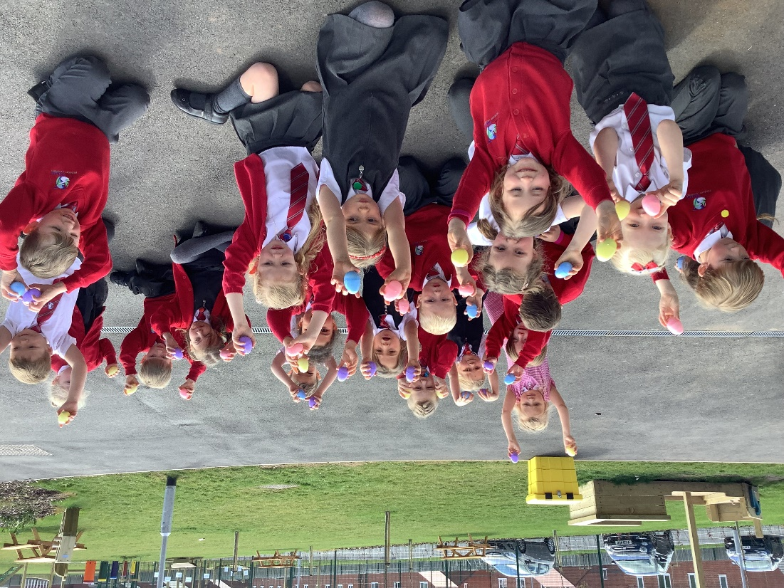
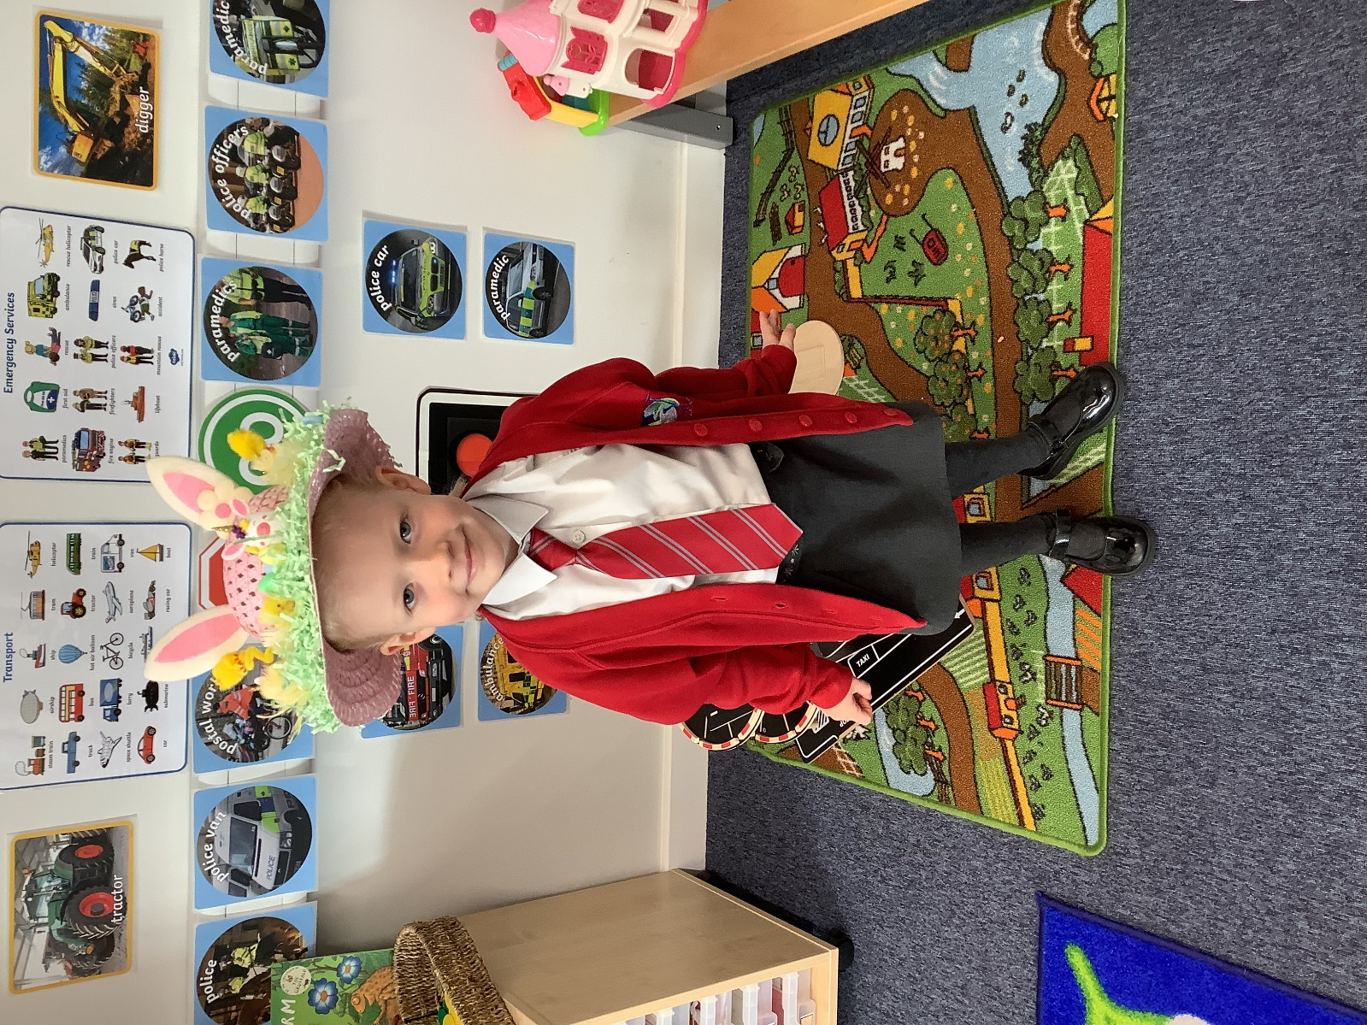
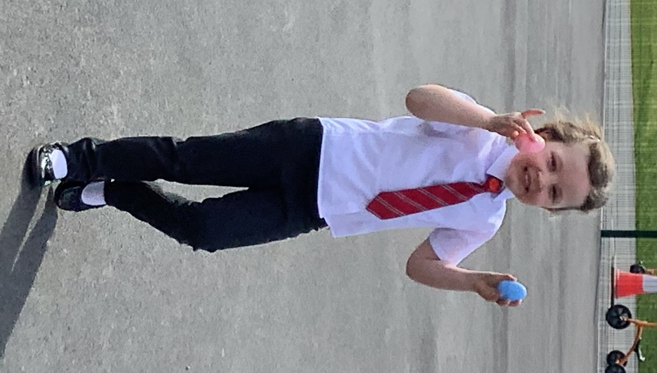

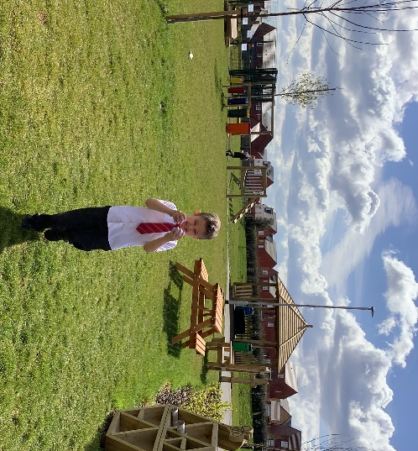



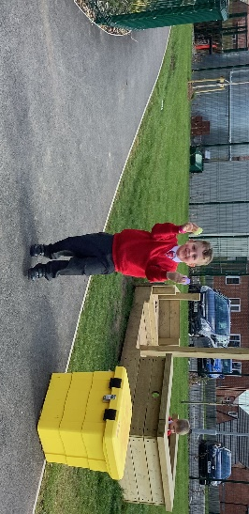
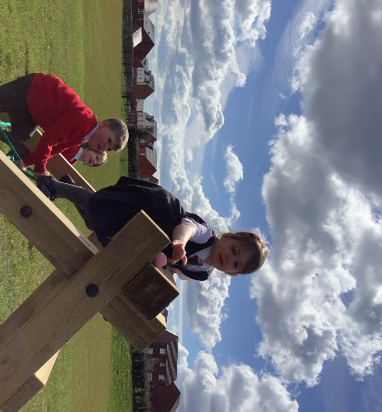
On the last day of term before breaking up for the Easter holidays, Dragonflies were lucky enough to get a visit from the Easter Bunny!
They enjoyed a big Easter egg hunt together, finding lots of colourful eggs dotted around the outdoor area - what a perfect way to finish off a fantastic Spring term!

