Number Day



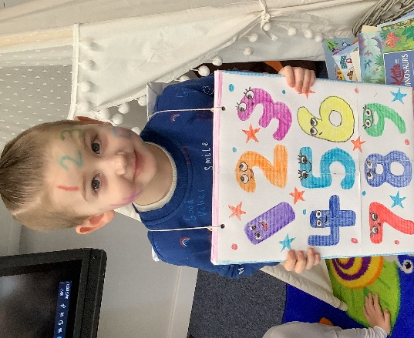
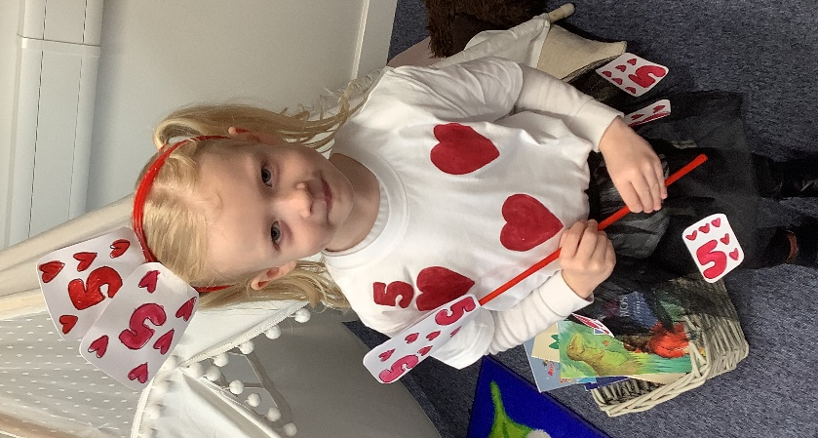
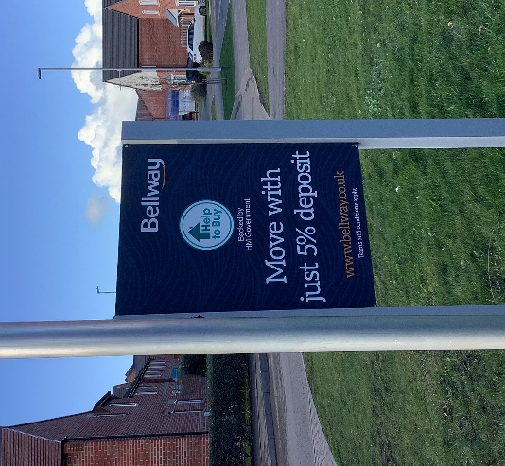
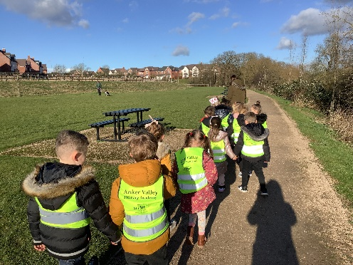
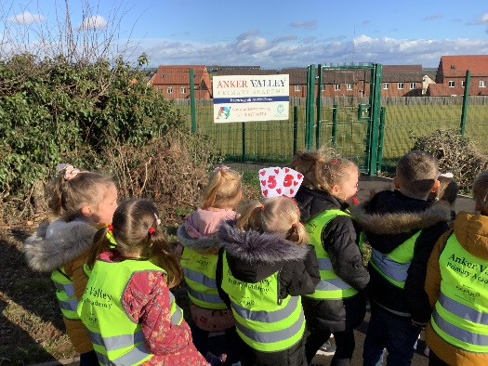
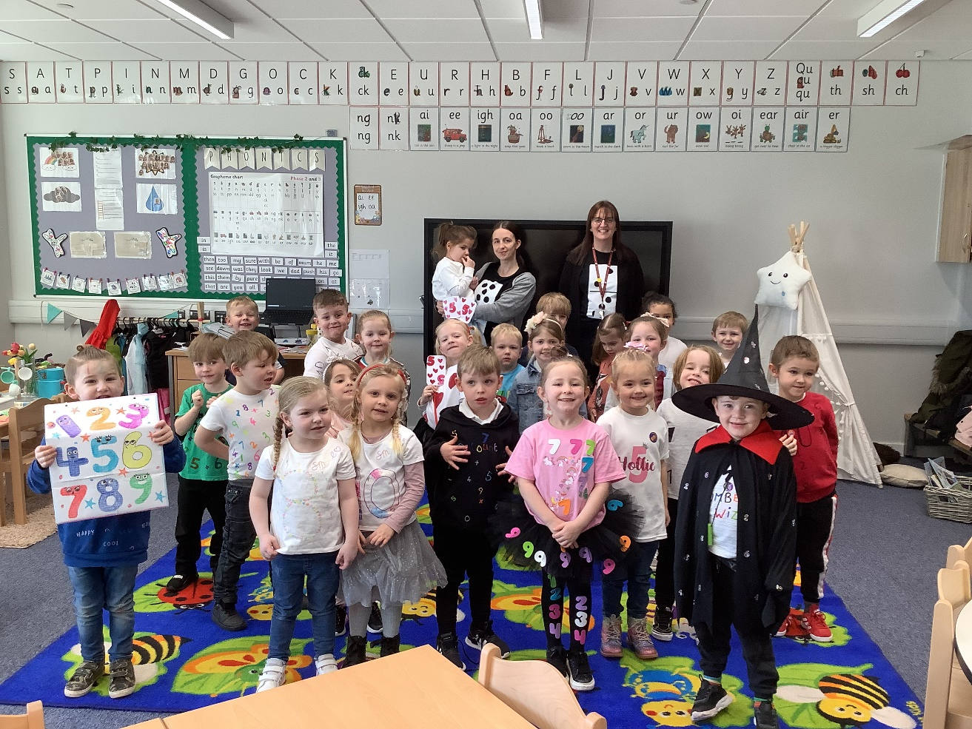
Friday 4th February
It was Number Day on Friday 4th February. Dragonflies came to school dressed as their favourite numbers - we saw so many creative costumes. The children got to go on a walk with Mrs Horlor, Mrs Free and Miss Garrett. They had to spot as many numbers as they could! They found numbers on houses, numbers on signs and even on cars. They spent the day doing lots of number activities using things like number fans and counters. They’re all very smart.

