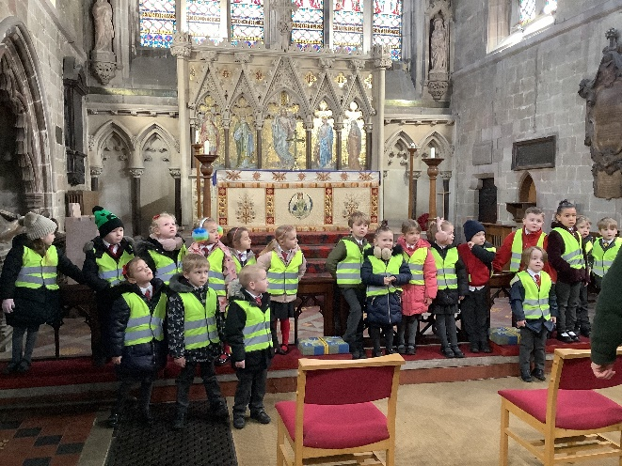
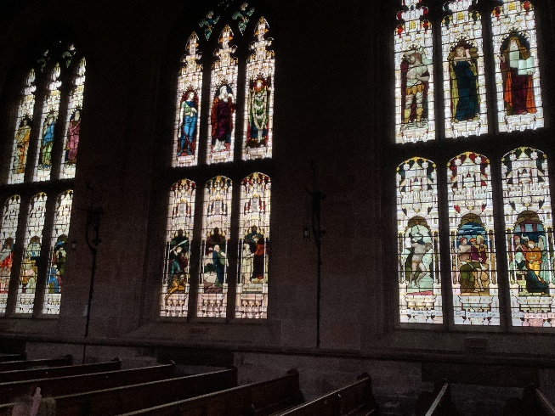
St Editha’s Church
Wednesday 8th February

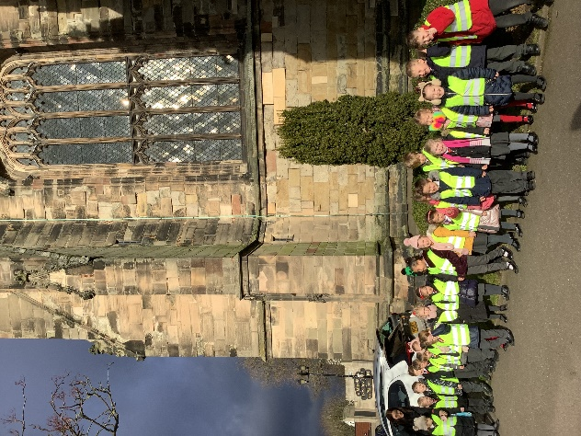
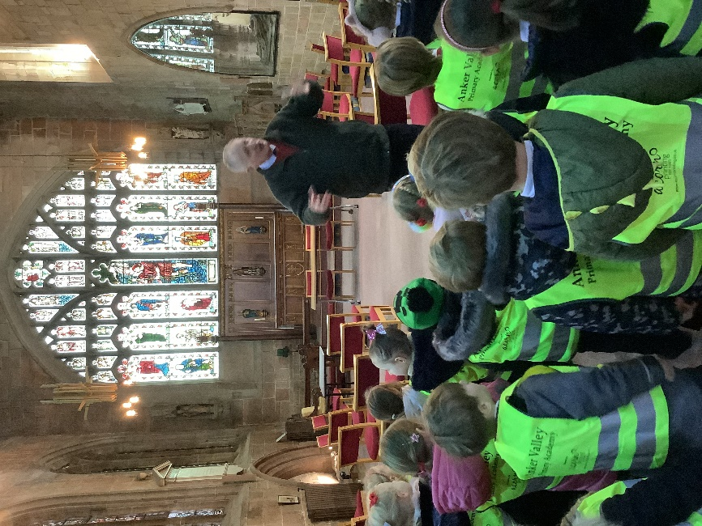
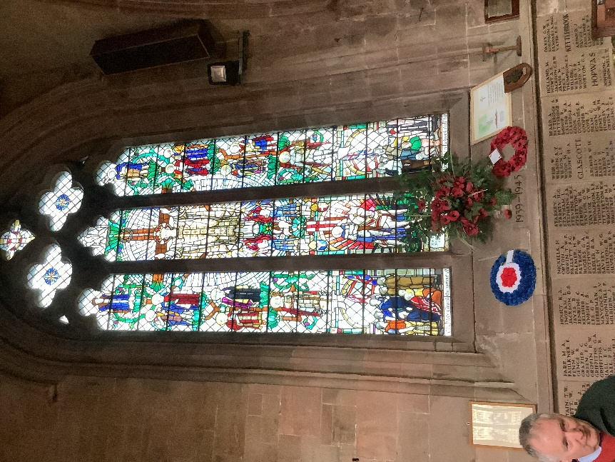
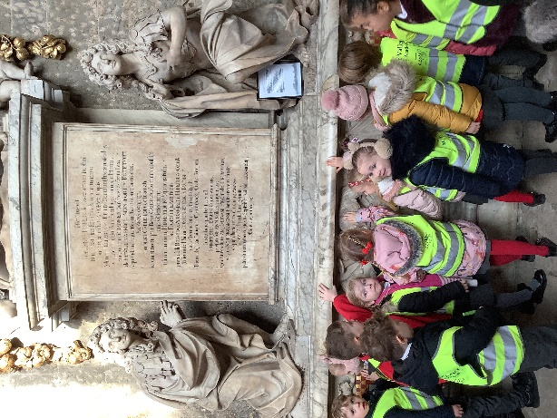
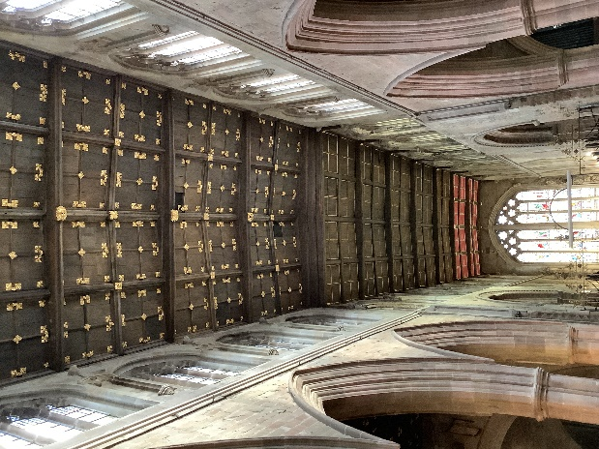
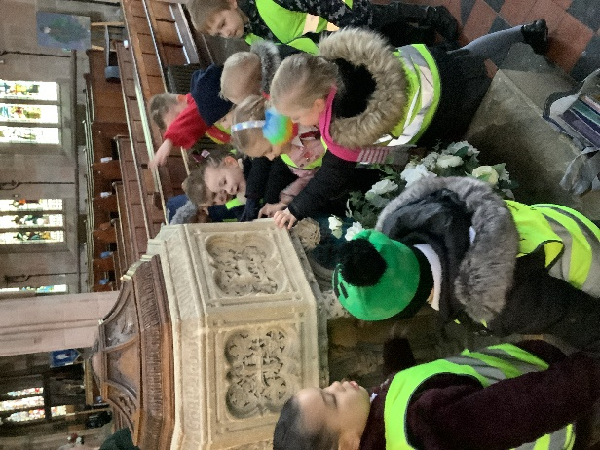
Dragonflies were so excited to visit St Editha’s Church. They were taken on a tour and learnt so much about the building, its stained-glass windows, the sculptures, statues, and lots of bible stories. They saw the steep staircase the bell ringers use to get to the top of the church tower and learnt that some parts of the building are from the eleventh century! They asked lots of questions and will soon be visiting Spital Church too.

