Bedtime Story
Monday 31st January
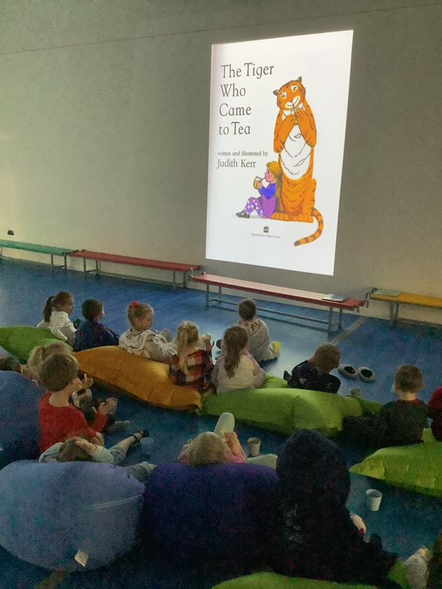
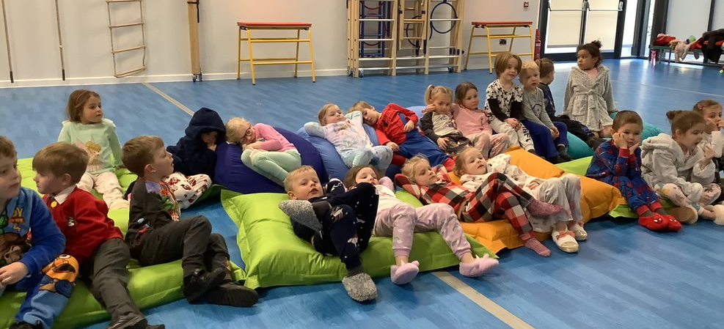
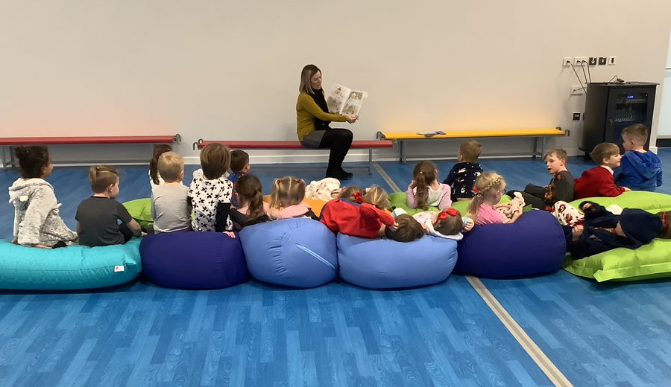

Dragonflies were invited to stay after school to listen to a bedtime story with Mrs Horlor, and then to watch ‘The Tiger Who Came to Tea’. They enjoyed a hot chocolate with a shortbread biscuit in their pyjamas, and then got cosy with their friends on the beanbags! Dragonflies had a great time, and we can’t wait to do this again in future.

