World Book Day
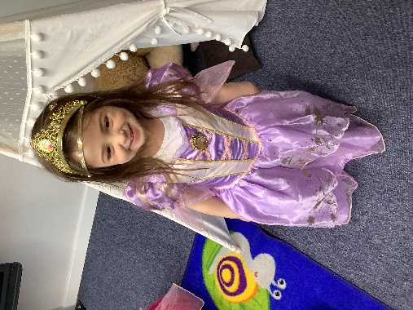
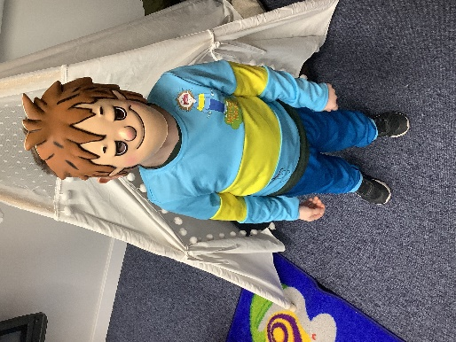
Thursday 3rd March
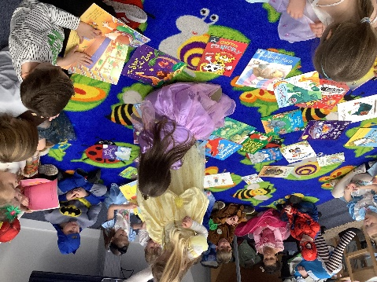
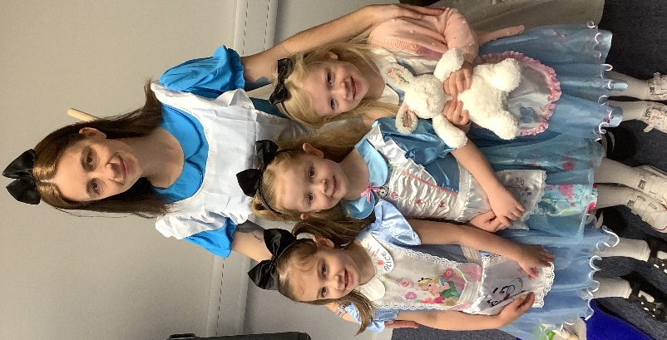
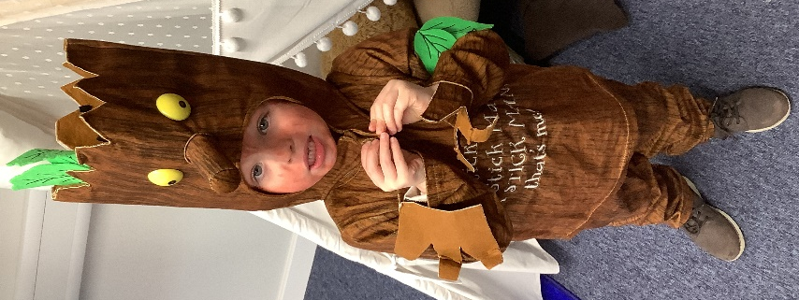
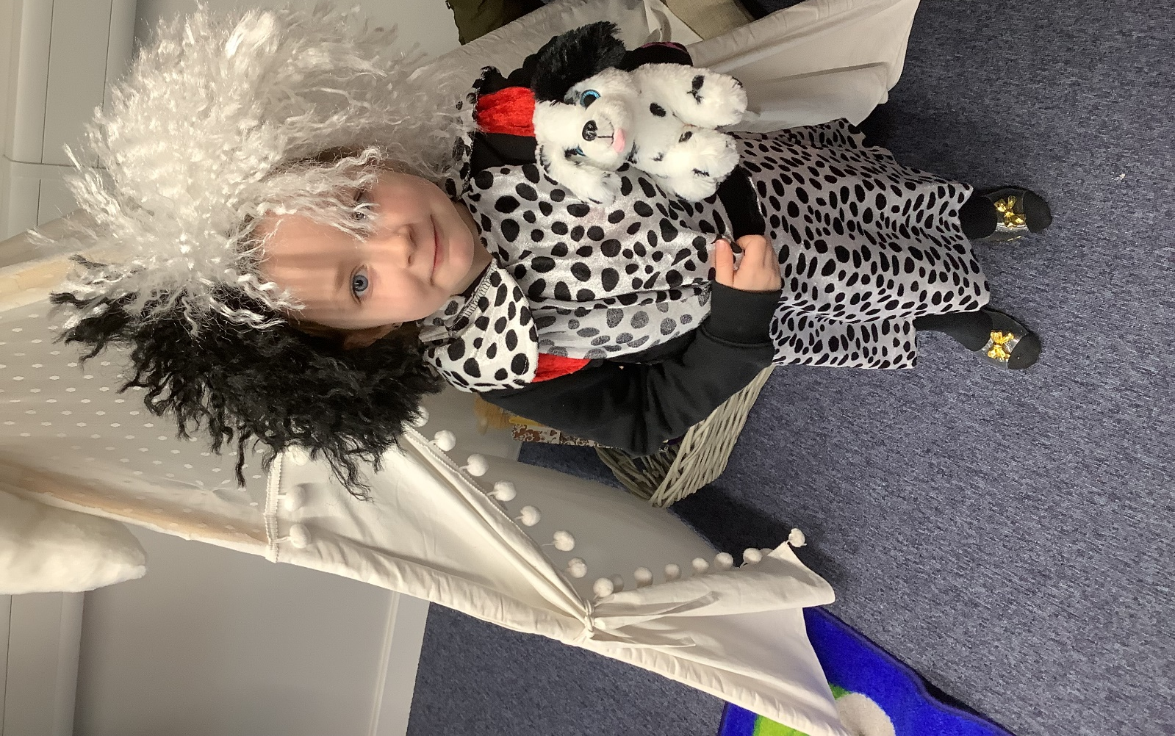

The children came into school on World Book Day dressed as their favourite book characters! We saw so many different outfits. Mrs Free and Miss Garrett even dressed up as Matilda and Alice in Wonderland!
Dragonflies also got to bring in a book from home so that they could do a book swap with the rest of the class – this way, they get to share some of their books that they have already read, and in return get someone else’s book so that they can read a new one.
The class enjoyed doing lots of different themed activities for World Book Day. Julia Jones, one of our governors, also came in to read everyone a story. They loved having a special visitor come into class.



