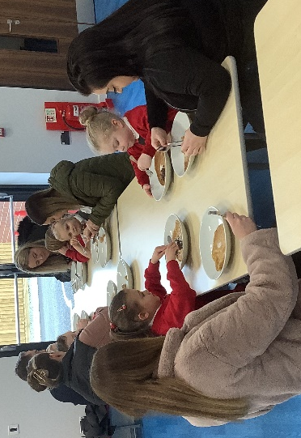
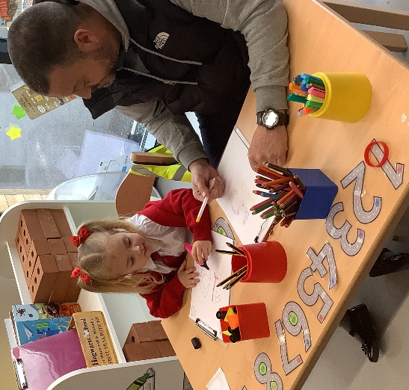
Pancake Day
Tuesday 1st March
Dragonflies had such a fun time at school for Pancake Day. They had a special visitor, Sue Rowley, to come and do a Shrove Tuesday Assembly in the morning!
They were so excited that their parents would be coming in after lunch to have pancakes with them. They all had a lovely time in the hall, and then parents were invited stay for the afternoon to see the amazing learning that takes place in class. Dragonflies loved showing off their skills.
To finish off the day, parents, staff, and children all walked to the courts to do the pancake races – even the adults joined in! They all won house points for taking part and some for finishing the race first. It was a great day.


Pancake Day!



